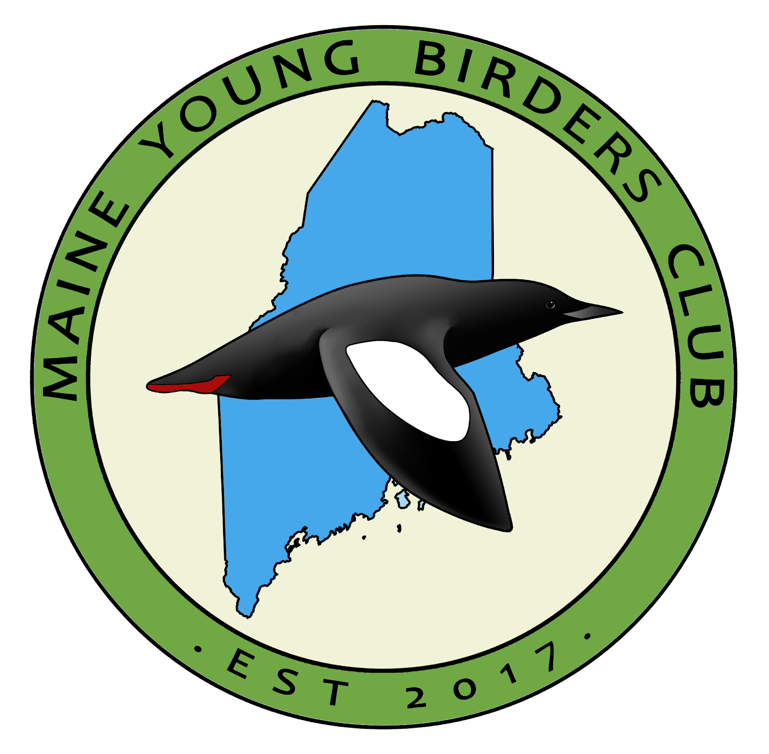 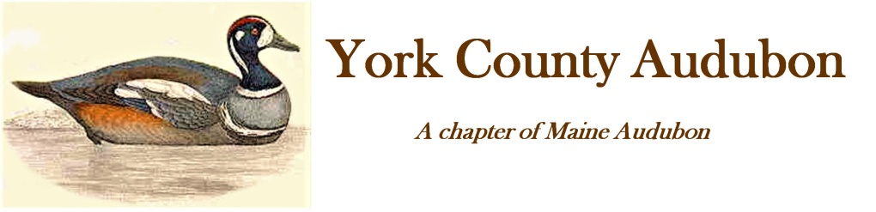

**2025 Scholarship: Coastal Maine Bird Studies for Teens**

York County Audubon (YCA), the Maine Young Birders Club (MYBC) and Friends of Hog Island (FOHI) have teamed up to offer a scholarship for teens (ages 14-17) to attend a summer camp on Hog Island, which has been a mecca for environmental education since 1936. The program, Coastal Maine Bird Studies for Teens, will take place June 15-20, 2025, on the 330-acre island in mid-coast Maine’s beautiful Muscongus Bay. It will be led by some of the nation’s most-respected naturalists and environmental educators.

The scholarships cover 100% of the $1,725 expense for the entirety of stay at Hog Island. The applicant agrees that after they complete the course, they will provide a brief write up about the experience to share with YCA and FOHI.

**Please submit your application by February 19, 2025 by email attachment to:** [**info@maineyoungbirders.org**](mailto:info@maineyoungbirders.org)

**Applicants will be notified of decisions by March 1, 2025.  
We will also notify applicants via email when their application is received.**

*********************************************************************************** **Coastal Maine Bird Studies for Teens, ages 14-17, June 15-20, 2025** This intensive 6-day, 5-night program on Hog Island allows enthusiastic young birders to work with some of the country's best-known birders and ornithologists on field identification, bird ecology, and conservation. Taking place concurrently with the adult Field Ornithology and Hands-on Bird Science sessions, and sharing many of the same instructors, this program includes the unique opportunity to see Audubon's seabird restoration work in action and is the only Hog Island program that lands participants on Eastern Egg Rock during the puffin breeding season (weather and sea conditions permitting).

Coastal Maine Bird Studies is for teens with an avid interest in birds and the outdoors. Limit of 16 participants per session. The teen must arrange for transportation to and from the Audubon dock in Bremen, ME, at the start and end of the session. About eight weeks before camp, you will be sent additional forms to fill out, including liability release, medical, and travel forms.

Questions: For questions regarding the program, registration, lodging or meals, contact the Audubon Camp program director at hogisland@audubon.org or (843) 340-8673.

A detailed program description can be viewed at: <https://hogisland.audubon.org/programs/bird-studies-teens>

*Please use a computer to type your answers to the questions below. You may type directly on this form.*

**BIOGRAPHICAL INFORMATION**

Name

_____________________________________________________________________________________

*First Middle Last*

______ ______________________________________________________________________________

*Number and Street City State Zip*

Telephone ______________________ Date of birth **_____________**

Email address: _______________________

**FAMILY**

Name of Parent/Legal Guardian: _______________________________

**EDUCATION**

Current High/Middle School: __________________________________

**PARENT/GUARDIAN PERMISSION**

I __________________ (*printed name of parent/guardian*) give permission for my child to apply for this scholarship and participate in the Coastal Maine Bird Studies for Teens summer program if they are awarded the scholarship.

__________________

*Parent/Guardian Signature Date*

**NOTE:** If you are submitting this application digitally, you may either print, sign, scan, and email this sheet to info@maineyoungbirders.org, or you may insert a digital signature onto this page in the form of a .jpg image file of your signature.

**INTERESTS AND ACTIVITIES**

* Please describe your current academic interests:
* Briefly describe your extracurricular activities:

**PERSONAL STATEMENT QUESTIONS**

*Please thoroughly answer the questions below in no less than 3 sentences. You can certainly write more! The more thorough and descriptive you are, the better we get to know you as an applicant. If you need more space in which to type out your answers, simply hit “enter” on your keyboard to create as much space as you need.*

1. Which environmental and bird-related topics interest you the most? What exactly “fires you up” and gets you excited about birds, birding, and/or natural history studies?
2. Why do you wish to attend the Coastal Maine Bird Studies for Teens camp? Why are you interested in this experience? How do you see yourself making the most of your time at the camp while you are there?
3. Recipients will be asked to provide a brief write-up (photos/drawings are welcomed too) about their experience to be published in the York County Audubon Harlequin and on the MYBC Newsletter. This will also be shared with the Friends of Hog Island.
4. **Passing it forward**. If you receive this scholarship, one of the requirements will be to carry out a community service project of your choice. In 2-3 paragraphs, describe how you will use what you learn at the summer camp to educate others and/or contribute. to your community in order to “pass it forward.” Some possibilities for community service projects include:

* Take kids on a nature walk
* Volunteer with a local land trust
* Volunteer at the Center for Wildlife
* Integrate what you learned at camp into an educational program that could be used by a local Land Trust or other educational program (For EX: White Pine Programs).

Take some time to flush out your ideas about what you would like to do in order to pass the gift of this experience on to your community. The above projects are just some possible options. Feel free to describe your own unique community service project idea. If you are uncertain about the specific details of the project that is okay—just describe generally what you might do. For whichever project you choose, be sure to explain why this particular project is interesting to you and how you might go about accomplishing your goal(s).

1. **Getting to know you**. Is there anything else you would like us to know about you, which might help us in evaluating your application? This is your opportunity to tell us anything you want about yourself. In 1-3 paragraphs, please describe something about yourself that will help us get to know you better. You may speak as broadly or narrowly as you would like, and you can share absolutely anything!